**AI ASSISTED CODING**

**LAB-3:** ***Prompt Engineering – Improving Prompts and Context Management***

**Roll No:** 2503A51L07

**Name:** Bathini Sahasra

**Batch:** 24BTCAICSB19

**Task-1 Description:** Ask AI to write a function to calculate compound interest, starting with only the function name. Then add a docstring, then input-output example

**Prompt:** write a function to calculate compound interest, starting with only the function name. Then add a docstring, then input-output example. Ask the user now for input to calculate the amount.

**Code Generated:**

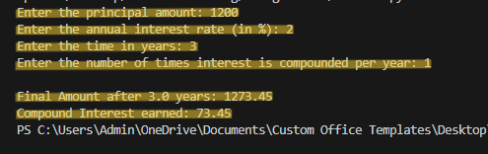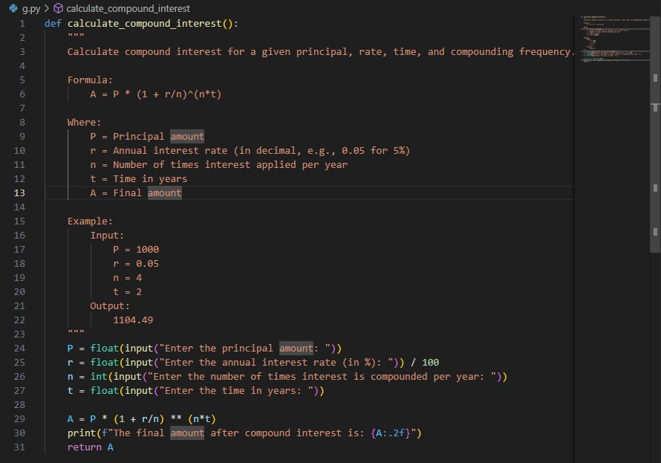

**Output:**

**Observation:**

Starting with only a function name and gradually adding docstrings and examples demonstrated how AI understands step-by-step instructions and builds code systematically.

**Task-2 Description:** Do math stuff, then refine it to: # Write a function to calculate average, median, and mode of a list of numbers

**Prompt:** # Write a function to calculate average, median, and mode of a list of numbers.

# And ask user to input a list of numbers separated by spaces.

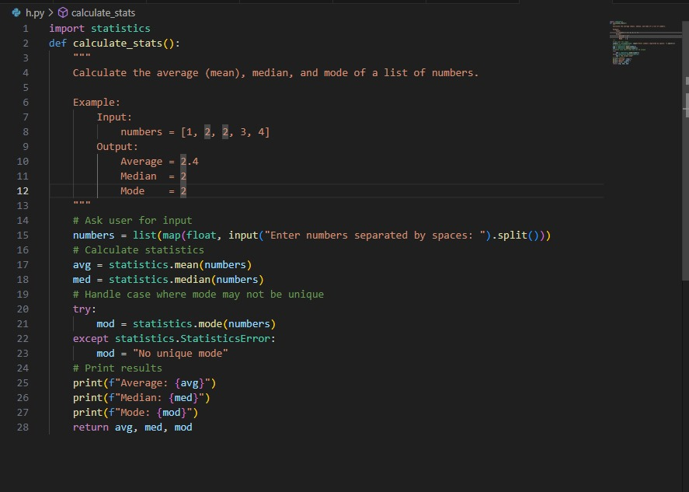**Code Generated:**

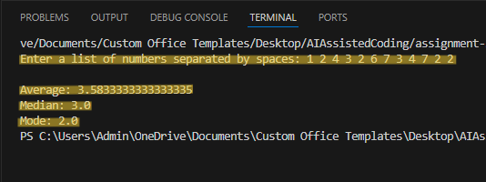**Output:**

**Observation:**

I observed how runtime inputs can be used for statistical calculations (average, median, mode), showing AI’s capability to handle mathematical logic on user-provided data.

**Task-3 Description:** Provide multiple examples of input-output to the AI for convert_to_binary(num) function. Observe how AI uses few-shot prompting to generalize.

**Prompt:** generate a python program that provides multiple input–output examples for a Python function convert_to_binary(num) that converts a decimal number into its binary representation.Let the user give inputs.

**Code Generated:**

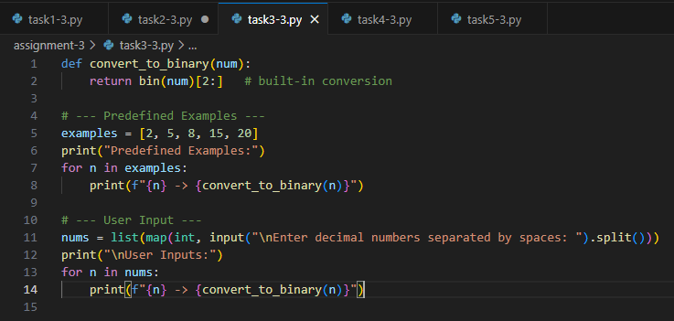

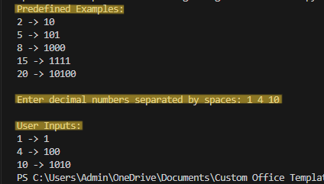**Output:**

**Observation:**

By providing multiple input–output examples for the convert_to_binary(num) function, I noticed how AI applied few-shot prompting to generalize and generate correct binary conversions for any decimal input.

**Task-4 Description:** Create an user interface for an hotel to generate bill based on customer requirements

**Prompt:** Generate a python program to Create an user interface for an hotel to generate bill based on customer requirements

**Code Generated:**

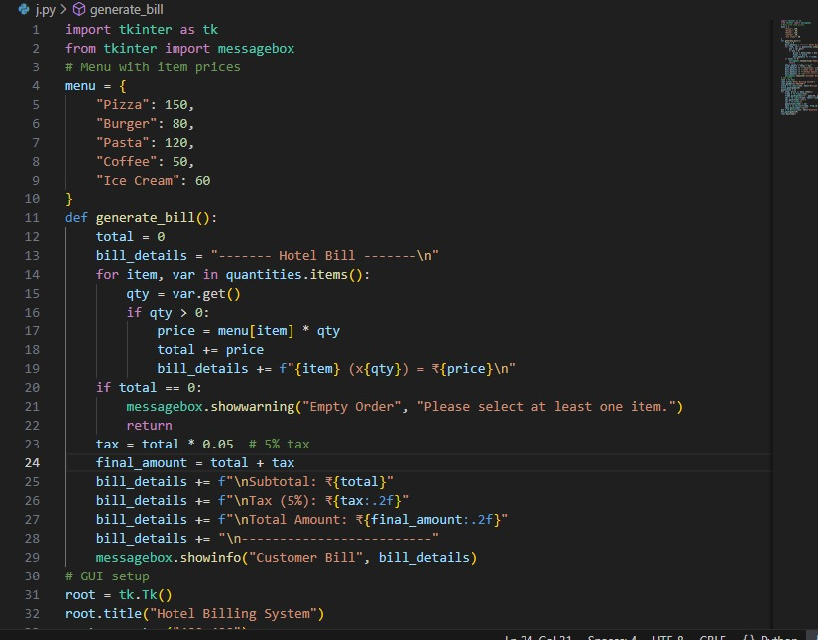

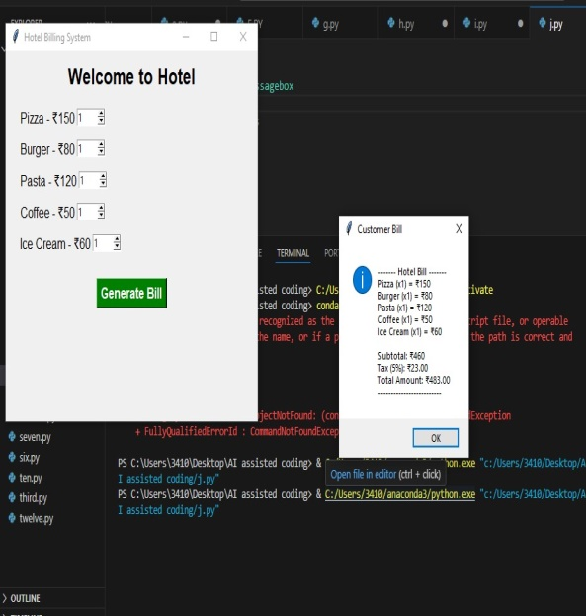**Output:**

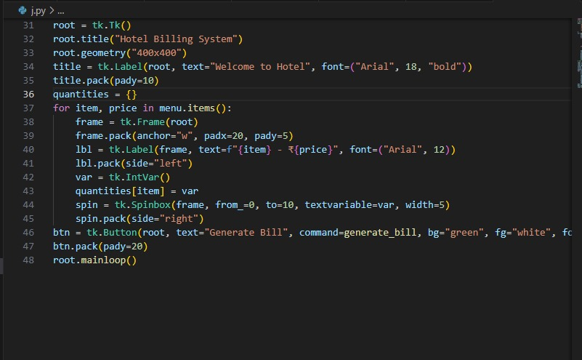

**Observation:**

The hotel billing program highlighted how AI can extend beyond simple functions to build user-oriented applications, combining logic with interface design.

**Task-5 Description:** Analyzing Prompt Specificity: Improving Temperature Conversion Function with Clear Instructions

**Prompt:** Generate a python program to Improving Temperature Conversion Function with Clear Instructions.

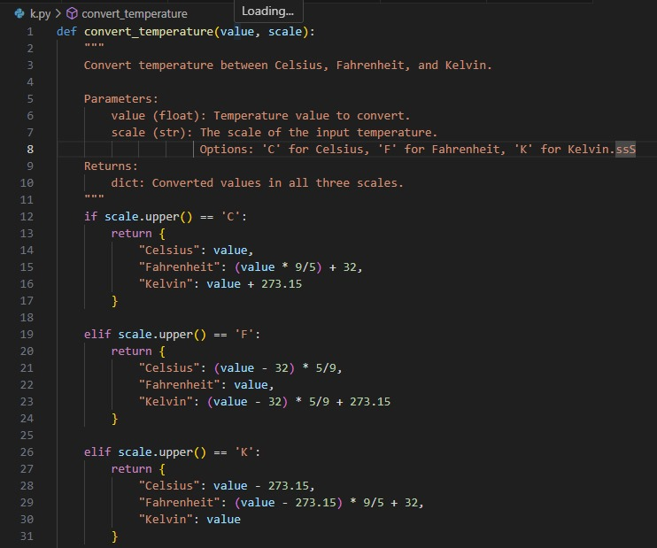**Code Generated:**

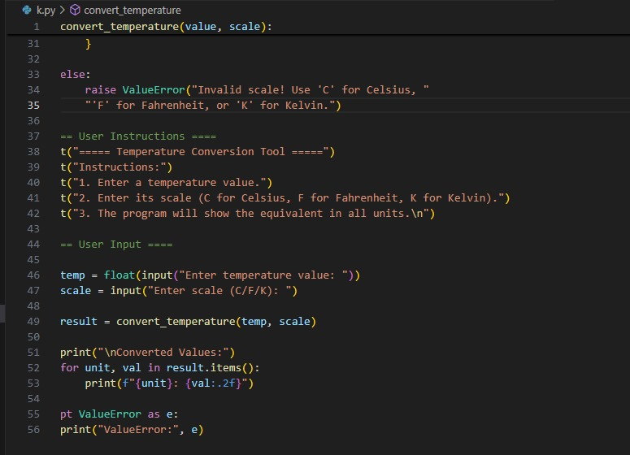

**Output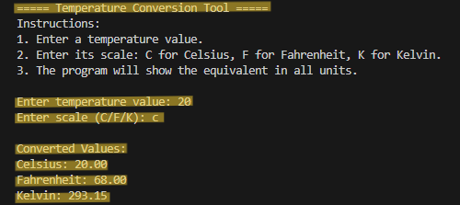:**

**Observation:**

Refining the temperature conversion function showed how prompt specificity directly affects the accuracy, clarity, and usability of AI-generated code.